# High Risk Construction Work Safe Work Method Statement

|  |  |  |  |  |  |  |  |  |
| --- | --- | --- | --- | --- | --- | --- | --- | --- |
| **NOTE:** Work must be performed in accordance with this SWMS.  This SWMS must be kept and be available for inspection until the high risk construction work to which this SWMS relates is completed. If the SWMS is revised, all versions should be kept.  If a notifiable incident occurs in relation to the high risk construction work in this SWMS, the SWMS must be kept for at least 2 years from the date of the notifiable incident. | | | | | | | | |
| APEX Labour | | | | **Principal Contractor (PC)** | |  | | |
| **Works Manager:**  **Contact phone:** |  | | | **Date SWMS provided to PC:** | |  | | |
| **Work activity:** | Traffic Control | | | **Workplace location:** | | Within the project and surrounds | | |
| **High risk construction work:** | ⬜ Risk of a person falling more than 2 metres (*Note:* in some jurisdictions this is 3 metres) | | ⬜ Work on a telecommunication tower | | | | ⬜ Demolition of load-bearing structure | |
| ⬜ Likely to involve disturbing asbestos | | ⬜ Temporary load-bearing support for structural alterations or repairs | | | | ⬜ Work in or near a confined space | |
| ⬜ Work in or near a shaft or trench deeper than 1.5 m or a tunnel | | ⬜ Use of explosives | | | | ⬜ Work on or near pressurised gas mains or piping | |
| ⬜ Work on or near chemical, fuel or refrigerant lines | | ⬜ Work on or near energised electrical installations or services | | | | ⬜ Work in an area that may have a contaminated or flammable atmosphere | |
| ⬜ Tilt-up or precast concrete elements | | **X** Work on, in or adjacent to a road, railway, shipping lane or other traffic corridor in use by traffic other than pedestrians | | | | **X** Work in an area with movement of powered mobile plant | |
| ⬜ Work in areas with artificial extremes of temperature | | ⬜ Work in or near water or other liquid that involves a risk of drowning | | | | ⬜ Diving work | |
| **Person responsible for ensuring compliance with SWMS:** | |  | | | **Date SWMS received:** | | |  |
| **What measures are in place to ensure compliance with the SWMS?** | | Traffic Control Licence (Blue, Yellow, Orange or Red Ticket), General WHS induction, Site induction, Induction into these SWMS | | | | | | |
| **Person responsible for reviewing SWMS control measures:** | |  | | | **Date SWMS received by reviewer:** | | |  |
| **How will the SWMS control measures be reviewed?** | |  | | | | | | |
| **Review date:** | |  | | | **Reviewer’s signature:** | | |  |

| **What are the tasks involved?** | **What are the hazards and risks?** | **What are the control measures?** |
| --- | --- | --- |
| List the work tasks in a logical order. | Identify the hazards and risks that may cause harm to workers or the public. | Describe what will be done to control the risk. What will you do to make the activity as safe as possible? |
| Planning and preparation | Failure to provide emergency assistance, Incorrect delivery route, commencement prior to DA authorized time | * Site induct all employees, comply with the required use of all PPE and follow the directions of the site management.   All workers are to be explained the workings of the TCP and the roles everyone is required to follow |
| PPE | General health | * PPE including hats, sunglasses, sunscreen and shirts are to be available as required. * Water bottles are recommended |
| Set up of equipment | Impact from vehicles | * Yellow card holder must implement the TCP as per the plan, any changes must be reported and authorised by the person who developed the TCP * Signage will be installed on each road progressively commencing from “Road Works Ahead” * Do not walk along the roadway carrying signs, use the footpath * A High Vis-Vest or Hi-Vis shirt with ‘Authorised Traffic Controller’ to be worn at all times. * Stop Slow batons are to be used to direct vehicles * Cones and delineation are to be installed after the signage * Vehicle will be used as protection as required |
| General requirements | Health | * During periods of inclement weather * Use rain jackets with Traffic vest over the top * Increase distance between signage and increase stopping distances * Take regular breaks in shaded areas * If TCP allows conduct stop/slow in shaded areas * Alert your teammates/supervisor if you are feeling dizzy, faint, flushed in the face, sweating profusely. * Drink fluids at regular intervals |
| Controlling traffic |  | * Ensure you have an escape route * Observe the traffic flow to ensure controls are identified for corners and entrances * Do not engage in any abusive or road rage behaviour * Any traffic incidents request the drivers to move to a safe area and allow them to exchange details you are only to provide your name and employers contact details |
| Review | Weekly checklist | * The TCP weekly checklist will be completed and provided to the site manager |
| Removal of equipment | Impact from vehicles | Signage will be removed from each road progressively concluding with “Road Works Ahead” |
|  |  |  |
|  |  |  |

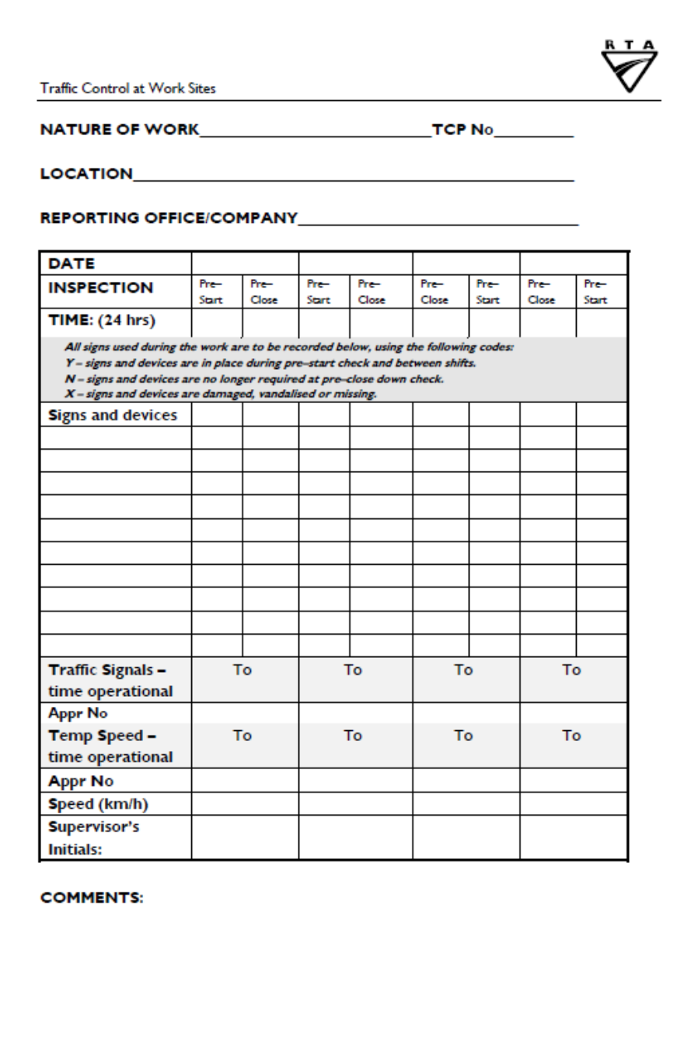

|  |  |  |  |
| --- | --- | --- | --- |
| **Name of Worker(s)** | **Worker signature(s)** | **RMS License – Type, Number & Expiry Date** | **Date** |
|  |  |  |  |
|  |  |  |  |
|  |  |  |  |
|  |  |  |  |
|  |  |  |  |
|  |  |  |  |
|  |  |  |  |
|  |  |  |  |
|  |  |  |  |
|  |  |  |  |
|  |  |  |  |
|  |  |  |  |
|  |  |  |  |
|  |  |  |  |
|  |  |  |  |
|  |  |  |  |
|  |  |  |  |
|  |  |  |  |
|  |  |  |  |
|  |  |  |  |
|  |  |  |  |
|  |  |  |  |
|  |  |  |  |